Sarnia Hockey Association 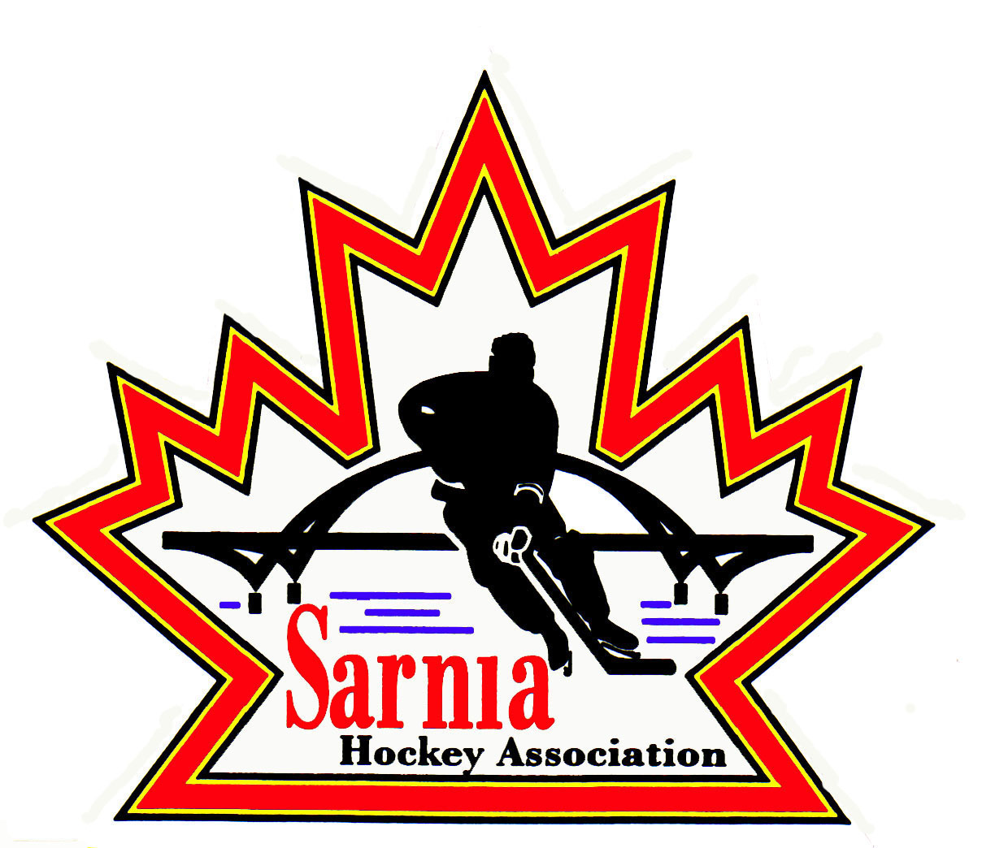

Minutes | Date DECEMBER 1, 2020 | time 7:00 pm

Meeting called by | Paul Walsh, Chairperson
Type of meeting | Due to the current state of emergency in Ontario as a result of the COVID-19 global pandemic and the Ontario Government’s direction regarding the need for social distancing to reduce the spread of the virus, a decision was made to meet via tele/video conference.
Secretary | Kelly Lane

Welcome | Paul Walsh, Chair welcomed everyone and called the meeting to order at 7:10 pm.

ATTENDANCE | Harry Chadwick, Paul Douglass, Ian Dunn, Chuck Ewart, Jim Felton, Pat Forbes, Kelly Lane, Cris Lapointe, Linda Lauzon, John Mellor, Ted Pendle, Wayne Scarrow, Kara Scott, Mark Stack, Lesley Smith-Taylor, Kevin Taylor, Tim Turner, Barb Walsh, Paul Walsh

ACCEPTANCE OF MINUTES | MOTION #201201-001  “That the Minutes from November 18, 2020 be accepted as presented.” (Pendle/L. Smith-Taylor)  Motion was Carried

TREASURER’s REPORT | No report.

BILLS TO BE PAID | MOTION #201201-002  “That the Bills be paid as presented.” (Pendle/I. Dunn)  Motion was Carried  If there are new participants we will be advising Aliiance and they will be invoicing us twice more for Insurance. We will be under the original budget.
  Recipient | Expense | Amount
  Ted Pendle  Linda Lauzon  Planet Stitch  Alliance  Patrick Sutton  City of Sarnia  Bonnie Marcy | Internet  December Honorarium  Rec jerseys  Part insurance for 869 participants  Level 2 coach certificate  Ice up to Nov 30  Transportation exp Nov | $38.40  $330.00  $9,103.28  $42,381.13  $96.05  $148,303.70  $50.00

BUDGET | SESSION # 3 BUDGET  - We used the master plan budget that was completed in May and fine tuned it based on ice availability and what we are projecting for the number of players based on the previous session.  - We have frozen the numbers for Rec and Rep.  - Outside of Instructional, the total registration costs including Rep, general registration and Midget/ Juvenile are all lower then last year and Instructional is slightly higher. This is because we have less participants to share the overall cost plus when we applied the surplus from last year, we applied it to everyone but Instructional as they weren’t involved in last year’s season.  - Rep - $900 (last year $1550)  - Rec $490 (last year $675)  - Midget/Juv $210 (last year $500)  - Instructional $380 (last year $300)  - Budget committee did a good job keeping our costs down and making it an affordable season with our modified play.  MOTION #201201-003  “That the Session 3 budget be adopted as presented.” (Pendle/Lauzon)  Motion was Carried

MESSAGE FROM THE CHAIR | The Chair thanked everyone for volunteering and for all of their hard work. It has been a frustrating year so far. There’s been a lot of information coming in from Hockey Canada, OHF, Alliance, the City, and Province and it’s been tough to plan the season. It’s been hard to implement the modified play and having the players and spectators follow the protocols. Organization has been difficult with conflicting information from the Alliance and OHF. Thanks to Kevin, Mark, Paul and Ted for working on the budget. Thanks to Barb and Harry for handling Rec equipment. We are doing a good thing for the players. Hoping volunteers will stick with it for next season.  COVID has changed our problems, and brought on new ones.  Our COVID Officer has had to deal with government at all levels which has been trying.  Thanks to Lesley for all of her work with registration and to Linda for managing the ice. Efforts are not going unnoticed and are appreciated.  The Chair thanked conveners. It’s hard monitoring divisions when you can’t be there. It’s important that we offer this programming for the kids and that’s what is most important.

NEW BUSINESS | POLICE CHECKS:  - A/AA – 100% compliant for police checks  - 85% for MD – 6 police checks outstanding  OUTDOOR ICE PROPOSAL:  MOTION #201201-004  “That SHA create a subcommittee to develop and lead a community effort proposal for an outdoor ice rink capable of being used for hockey.” (Chadwick/Douglass)  Motion was Carried with 4 opposed  Considerable discussion took place regarding the outdoor ice proposal that Councilman Bill Dennis brought forward to City council. The City turned down the proposal but all 9 council members supported the idea of an outdoor rink but half stated they wanted a community group to come forward and lead this. If a group came forward and raised some money the City would be interested in partnering.  If no organization comes forward, the idea will die, but if an organization or group of groups the City would be a willing partner.  SHA could be one of many users of an outdoor rink.  Community donors would need to support this initiative.  There was some concern expressed about this proposal infringing upon the other SHA proposal for Clearwater Arena that is currently being proposed to the City. Clearwater Arena proposal – we need to know if city is interested and then we build our plan and details. It will take a while to work out details. It is a massive undertaking. The wheels are in Motion.  We have support from other associations. It is going to Council.  There may be avenues from Sports Canada to help certain communitieis increase sport in their community. There is federal money for sport and infrastructure.  Need committee to review the obstacles and realistic costs.  Our commitment is to research what it would take to pull this off.  We need to talk to other groups.  The committee members will be Cris Lapointe, Harry Chadwick, Kevin Taylor, Lesley Smith-Taylor, Paul Douglass.  NEXT MEETING:  Next meeting via Zoom on 16 December – dress festive for Holiday cheer.

adjournment | MOTION #201201-005  “That the meeting be adjourned.” (Pendle/B. Walsh)  Carried

THE NEXT MEETING: Next meeting will be Wednesday December 16, 2020 via teleconference.

Paul Walsh Kelly Lane
Chair Secretary

